**Participation**

**Programme**

**Producer**

**Engagement Department**

**Permanent**



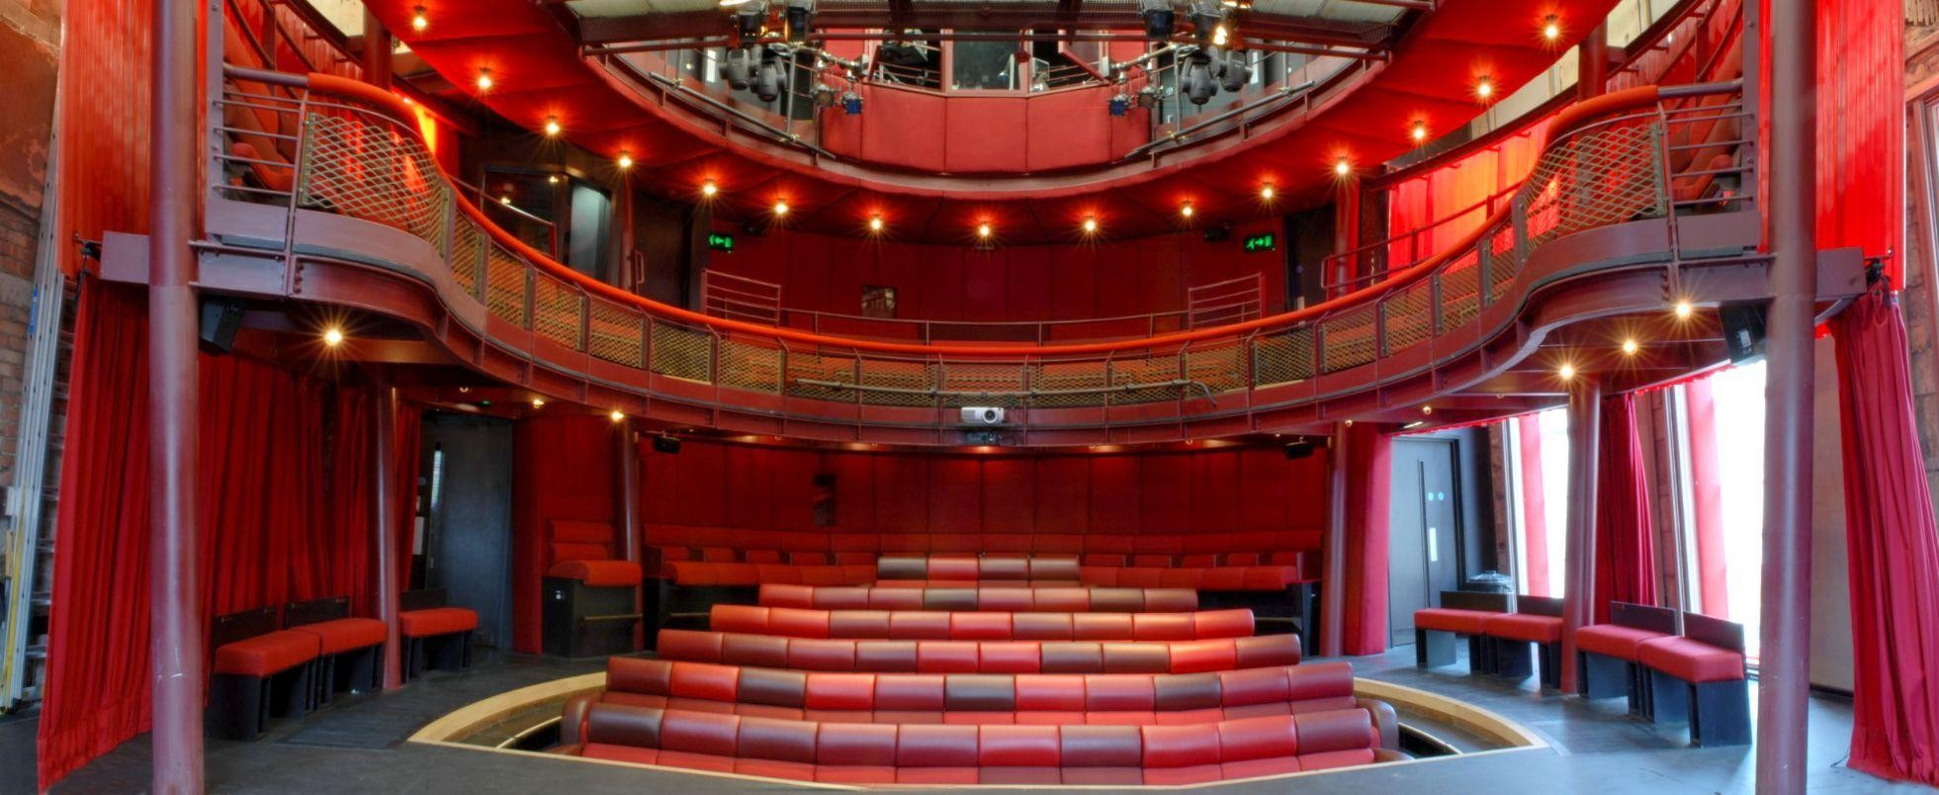

**Participation Programme Producer**

**The Egg, based at Theatre Royal Bath**

Dear Applicant,

Thank you for your interest in this role. We are pleased to be advertising this position and to find passionate and creative candidate to join our team at The Egg Theatre.

This opportunity arrives at a really exciting time for The Egg and Theatre Royal Bath (TRB) more broadly. We are in the process of building our community engagement offers with some new initiatives in development.

At The Egg, we are committed to fostering a diverse and inclusive workforce and we strive for equity in our recruitment and employment practices. In order to inspire and engage more people from diverse backgrounds, we need to actively work to address the barriers they face. In an attempt to do this, and to diversify our workforce by 20% by 2026 we are taking the ‘positive action’ of offering an interview to all global majority[1] applicants who meet the ‘Essential Criteria’ on the job description for this post. We also encourage applicants from low socioeconomic backgrounds and those living with a disability to apply. **Any final appointments will be made on merit**.

We are happy to makereasonable adjustments to help applicants feel more confident throughout the process, please don't hesitate to let us know how we can help.

If you wish to apply, please complete the [Equal Opportunities Monitoring form](https://forms.gle/JHf5twcBS7dZmYDK6) and email your CV and responses to our four questions on **page 8** to The Engagement Administrator. Or if you require this information pack in another format (e.g. Large Font, audio recording) please contact the Engagement Administrator, Tracey Cook: [tracey.cook@theatreroyal.org.uk](mailto:tracey.cook@theatreroyal.org.uk) / 01225 823 409

I enclose the following written materials:

1. Background to The Egg at Theatre Royal Bath
2. Job Description and Personal Specification
3. Participation Programme Producer Application Procedure

Details of how to complete the questions can be found at the end of the **Participation Programming Producer** Application Procedure document.

Please ensure applications reach us no later than 12 o'clock (noon) on **Friday 20th June**

Interviews will take place on **8th and 9th July** and you will receive notice of your call to interview no later than **27th June**

The application process will include a formal interview, including three short pre-prepared tasks.

Thank you for your interest in Theatre Royal Bath and I look forward to hearing from you.

Yours sincerely,

Janine Solomon-Gardner

**Head of Engagement**

Participation Programme Producer

Job Description

**Job Title:**  **Participation Programme Producer (ages 5-18)**

**Department:** Engagement, The Egg

**Hours**: 40 hours per week from 9am to 6pm, Monday to Friday, although some flexibility of hours will be necessary in order to fulfil the

requirements of the post.

**Salary & benefits:** **£30,000 per annum**

**Term:**  Full Time

**Reporting to**: Head of Engagement

**Responsible for**: Freelance Practitioners, Production Teams, Workshop Assistants, Volunteers & Placement Students

**Location:** Theatre Royal Bath - primarily office based

**Benefits:** Complimentary tickets for most productions at each of the three auditoria (the Main House, Ustinov Studio, The Egg) Theatre ticket and travel budget (beyond Bath)

4 weeks holiday rising to 5 weeks after first year + Bank Holidays **Objectives:**

* Produce all non-formal education output, ranging from small-scale scratch sharings to fully staged and professionally-staffed productions in The Egg theatre, and a variety of venues in Bath
* Artistic and logistical programming of extra-curricular learning opportunities / experiences for Youth Theatre students, 5 - 18 years.
* Widen the participation pool of candidates through extended outreach opportunities
* Ensure that the Youth Theatre is embedded within the wider TRB community by championing its output and maintaining its profile across the organisation
* Create and develop opportunities for freelancers to develop their creative and educational practice through working with young people
* Strengthen the creative ecology of the South West through offering a range of freelance opportunities

**Responsibilities**:

(Whilst you will be responsible for the listed activities below, the whole department works as a team, supporting and collaborating where possible.)

This list of responsibilities is not exhaustive and may change as the strategic vision for the department and organisation evolves.

* To create, develop, and project manage all non-formal education work including early years provision, youth theatre and youth theatre outreach.
* To make both creative and financial decisions that best serve, support and inspire: the community, individual participants and the organisation.
* To produce all plays, projects and learning programmes that are offered to youth theatre members
* To maximise income for all youth theatre led participation enterprises.
* To create and maintain all budgets associated with early years, youth theatre projects and productions.
* To create all brochure and marketing materials in relation to the relevant projects and productions, alongside the relevant members of The Egg team and the Marketing Manager.
* To seek out, appoint, train (as appropriate) and line manage freelance assistants, practitioners and creatives that best suit the role creatively and/or inspire that specific group of participants. All the while ensuring that they maintain the same high standards as would be expected of in-house staff.
* Working closely with the Head of Engagement and the Youth Theatre’s team of freelance directors to steer the overall vision for both the artistic and operational elements of the youth theatre, and its digital /practical output.
* To line manage any student placements, while ensuring they are supported pastorally and professionally throughout their placement.
* To seek out, maintain and nurture relationships with local charities, youth organisations, consortiums and universities, bridging the gap between them and our in-house provision
* Alongside the Head of Engagement, investigate ways of further developing opportunities for the Youth Theatre through working with and maintaining relationships with: technologists, practitioners, and digital practitioners.
* Alongside the Development Manager, seek out funding applications to best serve the community projects and productions.
* To be an advocate for accessibility and continue to research and embed access in our participatory programmes.
* To track and evaluate all youth participation work, keeping in mind the drive for retention, satisfaction and artistic rigour.
* To collaborate with the whole Engagement department to ensure that we are making best use of our shared resources and spaces.
* To be aware of and comply with Health and Safety and Child Safeguarding issues relating to the department’s work, and sit on the in-house Child, Young People and Vulnerable Adults Committee.
* To retain awareness of best practice internationally & profile The Egg in national conversations

**Organisation-wide responsibilities:**

* Preparing reports for the Egg Director, Development team, and other stakeholders as required
* Setting and adhering to budgets and abiding by the financial systems and practices laid out by the TRB Finance Department
* Attending internal and external meetings as required, including departmental meetings and three all-staff meetings per year, acting as a champion for the organisation
* Always acting in the best interests of TRB and acting as an ambassador for The Egg
* Working with The Egg staff to develop and promote The Egg’s aims, policies and development plan
* Complying with Health and Safety and Child Safeguarding issues relating to the department’s work
* Complying with TRB’s Respect at Work policy
* Undertaking any further training as specified and agreed
* Contributing to the work of one of the cross-building work-force groups

Participation Programme Producer

**Person Specification**

In completing your application, please refer to the Person Specification outlined below. We do not expect you to possess all the criteria; however, those in bold are considered **Essential.**

**Experience**

* **At least three years of professional experience in an arts and/or education environment and /or producing**
* **Experience of working with young people**
* **Experience of producing plays / project management**
* **Experience of managing budgets**
* **Experience of working independently and as part of a team**
* Experience working with outreach, charitable and/or community groups

**Skills**

Essential

* **Demonstrably strong administration and organisational skills, and the ability to work to deadlines**
* **Ability to balance a varied workload and competing priorities**
* **An ability to communicate a passion for the arts to a range of stakeholders, from students to parents, freelance practitioners and partner organisations**
* **Ability to forge energetic relationships with stakeholders**
* **Computer literate with good working knowledge of the Microsoft Package**
* **Ability to maintain accurate and up-to-date records**

Desirable

* Experience working in SEN setting and a passion for facilitating spaces for young people with varied abilities.
* Generating creative ideas and understanding how to support others in doing the same
* An understanding of how to manage people, expectations and outcomes
* An understanding of theatrical processes, forms and possibilities
* A creative and outcome-led approach to problem solving
* A good head for marketing and social media campaigns
* Digital producing or understanding of the digital theatre landscape

## Knowledge

* **Be knowledgeable about those areas of the UK theatre scene that interest you most**
* **Understanding of the principals behind EDI (Equality, Diversity and Inclusion)**
* Good working knowledge of safeguarding procedures and best practice
* Knowledge of the local community of Bath and the South West
* Understanding of both formal and informal education in England

**Qualifications**

* **Relevant / transferable qualification OR an academic certificate / industry-specific training scheme OR evidence of continued professional development**
* A First Aid qualification or the willingness to train for this qualification

**Personal Attributes**

* **A passion for live theatre. An avid theatregoer with a rigorous dramaturgical mind and an interest in exploring that with young people.**
* **An interest in the social issues impacting children and young people**
* **An advocate for community arts and youth theatre being created to high artistic standards**
* **A motivated self-starter looking to apply energy and enthusiasm to achieve excellent results**
* **Ability to work in an office environment**
* **Ability to work collaboratively as well as independently**
* **Confident, approachable, and good humoured**
* **An organised mind that can process and prioritise a range of administrative tasks**
* **Intuition and ability to read the room of both young people and adults**

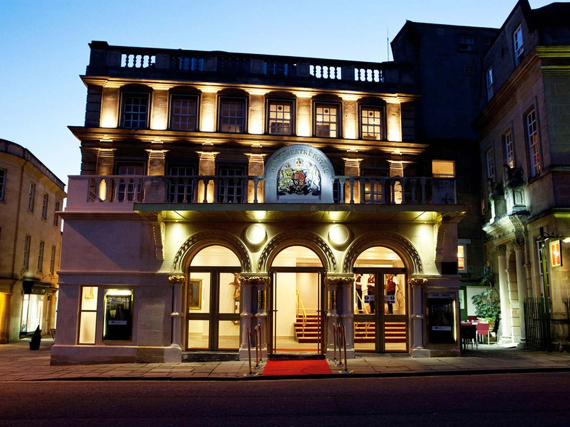

**The Egg at Theatre Royal Bath**

**About us**

**Egg Mission Statement**

The Egg is a theatre for curious and young minds, where we explore the joy of being human through shared theatrical experiences.

**The Egg**

The Egg, part of Theatre Royal Bath, is one of the country’s most established theatres dedicated to children and young people. Since opening in 2005, it has presented over 900 plays, programming 60 different professional productions each year for audiences aged 0-18, hosting hundreds of theatre companies and introducing thousands of young people to live theatre.

The Egg team works with many organisations to extend the role that arts and cultural venues play in young people’s lives, and fosters careers in the arts through: a partnership with Bath College delivering the Level Three qualification in Performing & Production Arts; apprenticeships; a Youth Theatre for ages 5-18; creative participation for 18+; strong links with Bath Spa University and Bath Cultural Education Partnership; a new Pipeline project offering work-based learning opportunities to people from backgrounds and heritage who experience systemic under-representation in the theatre industry; and the Incubator, the Egg’s ideas development programme.

The Egg operation broadly falls into two subsections, which we sometimes call departments, but we share the same office and are viewed as a single entity. These are:

**Building and Productions (The Egg)**. The toured-in programme, producing, touring and all things Theatre for Young Audiences. Consists of Egg Director, Egg Manager and Audience Development Officer.

**Engagement**. This department broadly covers all participation, education and engagement activity. This includes the delivery of Level 3 Performing Arts, schools’ liaison, delivery of all out-of-school creative learning including our youth theatre, digital experiences, early years provision and adult creative learning. Consists of Head of Engagement, Education Producer, Education Coordinator, Participation Programme Producer (Young People), and Head of Community Engagement (Adults).

The Egg also has a full time Administrator and makes use of casual receptionists, front of house, workshop assistants and freelance practitioners.

**Youth Theatre**

There has been a youth theatre in residence at Theatre Royal Bath for just under 40 years. During this time, it has been called many names, including Young Person’s Theatre (YPT) and Theatre Royal Bath Theatre School (TRBTS), and has been housed within all three of our auditoria. Currently housed in The Egg Theatre, the youth theatre offers specialised training and professional insight into the world of theatre, both on stage and off.

From Main House large scale productions to site-specific projects, fully remote digital productions to touring to the National Theatre - creative ambition and innovation has always been at the heart of what we do. We believe that all young people should have access to exceptional experiences and take pride in the diverse theatrical eclectic offer we can give to the young people of Bath and beyond.

**Our Funding Model**

TRB is a charity organisation with three auditoria: The Main House, Ustinov Studio and Egg Theatre. It also has a commercial trading subsidiary that produces and tours commercial work around the country and in the West End. Therefore, TRB is not reliant on Arts Council England funding for its existence. The Egg is funded by the profits made by TRB Productions.

Although part of The Egg, Bath Theatre Academy is mainly funded by a collaboration with Bath College.

**Who we are looking for;**

Based within the Engagement Office at Theatre Royal Bath, the **Participation Programme Producer** is a key member of the Engagement team. You will uphold the idea that theatre should be a space that is open to all, as well as constantly challenging the place of children and young people in society.

The successful candidate will be an advocate for inclusivity, a believer in the power of artistic expression & ambition, a dreamer, and a skilled collaborator.

We are seeking a project producer who has both a creative and outcome-led approach to problem solving. Someone who is passionate about youth theatre and making relevant, ambitious and exciting work with young people; an individual who has the skill of communicating and sharing this passion with parents, young people, colleagues, charities and collaborators.

The successful candidate needs the confidence to build and maintain a network of practitioners and creatives, while fostering energetic relationships with them. The Egg is dedicated to contributing to the already thriving creative ecology of the South West. The **Participation Programme Producer** will be responsible for advocating for creatives in the local area and beyond, while having young people’s learning and theatrical development at the heart of their decision making.

Working alongside members of the Engagement team, the **Participation Programme Producer** is both a strategic and creative producer role. You will programme and manage all non-formal education offers, and oversee the growth in our outreach work. You will curate and programme all work offered to young people from early years to 18, ensuring a creative, cohesive and robust experience. You will produce the work they make and be the advocate for high quality extracurricular arts experience within the department. This role already has steady foundations, but offers the opportunity to be developed to suit the ambitions of the candidate.

We are looking for a candidate who has vision and tenacity to maintain and develop our youth participation offer, to understand and implement best practices and to maintain a high standard of excellence for all extra-curricular operations and programmes.

The normal place of work will be the Engagement office, Theatre Royal Bath with some travel as required.

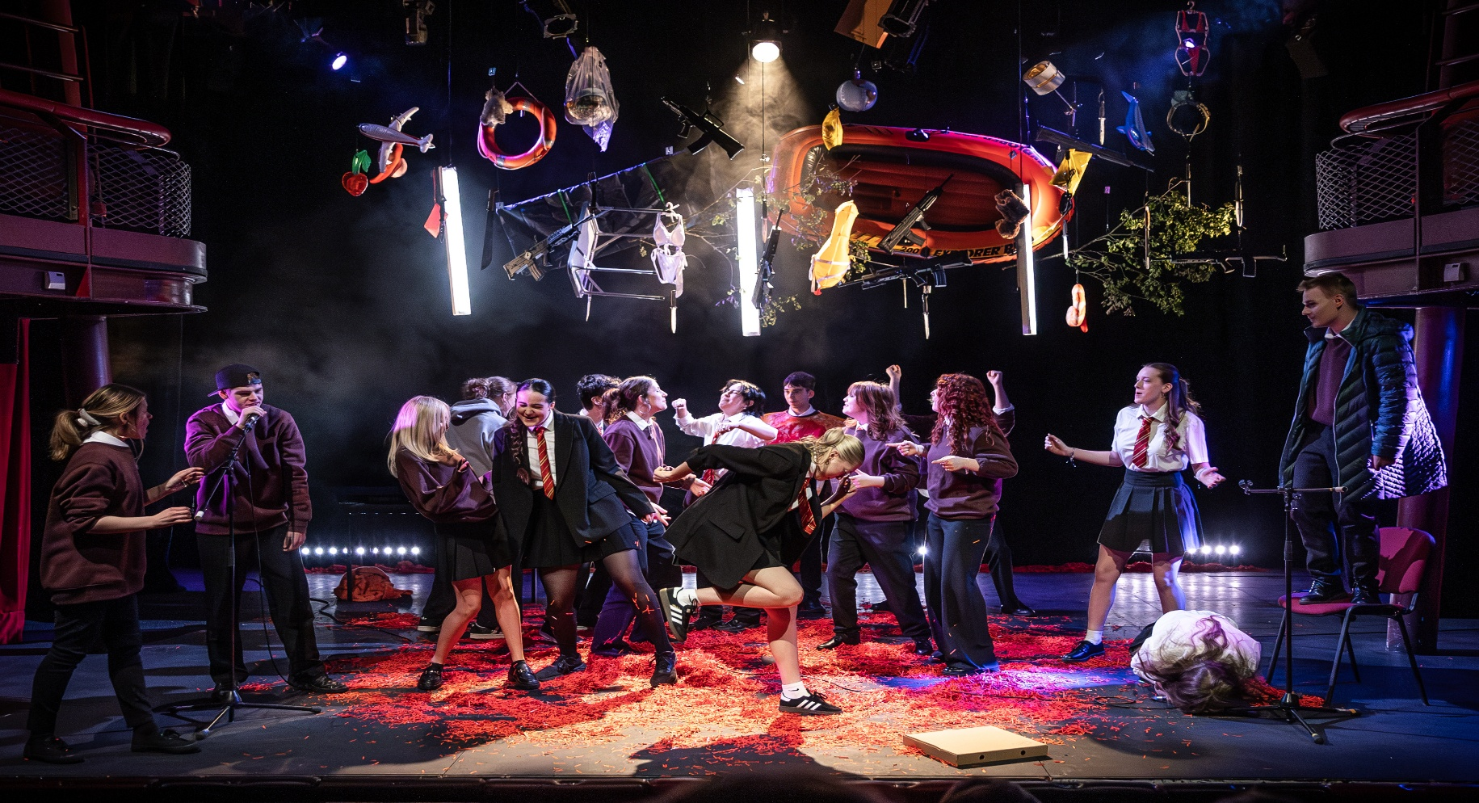

Participation Programme Producer

Application Procedure

**Deadline for Applications:** **Friday 20th June 2025**

**First Stage Interviews:** **Tuesday 8th July or Wednesday 9th July 2025**

Any offer to a successful candidate will be conditional upon:

* Receipt of at least two independent written references, which are satisfactory to Theatre Royal Bath. N.b: References produced by candidates will not be accepted.
* Verification of identity and Right to Work in the UK to be produced at interview stage.
* Returning a satisfactory DBS check.

**Application Procedure**

Please submit an up-to-date CV (2 pages max, PDF format) and respond to the four questions below.

We are interested in what you say rather than how you say it. Please apply in the format that best suits you and enables you to respond fully to the role. This could be written English, video (BSL/spoken, English/SSE), or an audio recording.

**Questions**

If answering in written form, please use no more than 400 words per question.

If answering in audio form, please ensure recordings are no longer than 2 minutes per question.

If answering in video form, please ensure recordings are no longer than 2 minutes per question.

1. **What kind of work do you want to make with young people?** We are asking this question to get an idea of why you are applying for this position and what interests you about Theatre Royal Bath’s Youth Theatre.
2. **How are you suited to this role?** We are asking this question to hear about how your experience, knowledge and skills match the person specification.
3. **Tell us about what inspires and excites you in life. (It doesn’t have to be theatre.)** We are asking this to learn more about you and what matters to you.
4. **Tell us about a challenging situation you faced at work and how you dealt with it.** We are asking this to learn how you face challenges or stressful situations.

*Please email your CV and answers to your questions to: [tracey.cook@theatreroyal.org.uk](mailto:tracey.cook@theatreroyal.org.uk) (quoting Participation Programme Producer in the subject line).

We recommend using WeTransfer to send video files.

1. **Global Majority -** refers to the majority of the world's population who are not white, and who are often racialized or considered to be ethnic minorities. This includes Black, Asian, Brown, dual-heritage, indigenous, and other ethnic groups. 