**FRONT OF HOUSE MANAGER**

**Theatre Royal Bath**

Dear Applicant,

Thank you for your interest in this role. We are pleased to be advertising this position and to find an efficient, approachable and motivated candidate to lead our excellent Front of House team at the Theatre Royal Bath and further develop a positive customer experience.

At the Theatre Royal Bath, we are committed to fostering a diverse and inclusive workforce and we strive for equity in our recruitment and employment practices. In order to inspire and engage more people from diverse backgrounds, we are endeavouring to actively work to address the barriers they face. In an attempt to do this and to further diversify our workforce, we are taking the ‘positive action’ of offering an interview to all global majority applicants who meet the ‘Essential Criteria’ on the job description for this post. **Any final appointments will be made on merit**.

We are happy to make reasonable adjustments to help applicants feel more confident throughout the process. Please don't hesitate to let us know how we can help.

If you wish to apply, please complete the [Equal Opportunities Monitoring Form](https://forms.office.com/Pages/ResponsePage.aspx?id=TZu2HhCM6Uu_UEx5jHkBTS_zO611UkZDgGfWW4Aiqw9UQVI1NEtaS0UyMThWNEVOWDc4WEVKT01VSy4u)  and email your CV and responses to our three questions (below) to Lydia McCotter: [recruitment@theatreroyal.org.uk](mailto:recruitment@theatreroyal.org.uk)

I enclose the following written materials:

1. Background to the Theatre Royal Bath
2. Job Description and Personal Specification
3. Front of House Manager Application Procedure

Details of how to complete the questions can be found at the end of the **Front of House Manager** Application Procedure document.

Please ensure applications reach us no later than 12 o'clock (noon) on **Wednesday 13 August 2025.**

Interviews will take place on **Monday** **18 and Tuesday 19 August** and you will receive notice of your call to interview no later than **Friday 15 August.**

The application process will include a formal interview.

Thank you for your interest in Theatre Royal Bath and I look forward to hearing from you.

Yours sincerely,

Eugene Hibbert

General Manager

**Theatre Royal Bath**

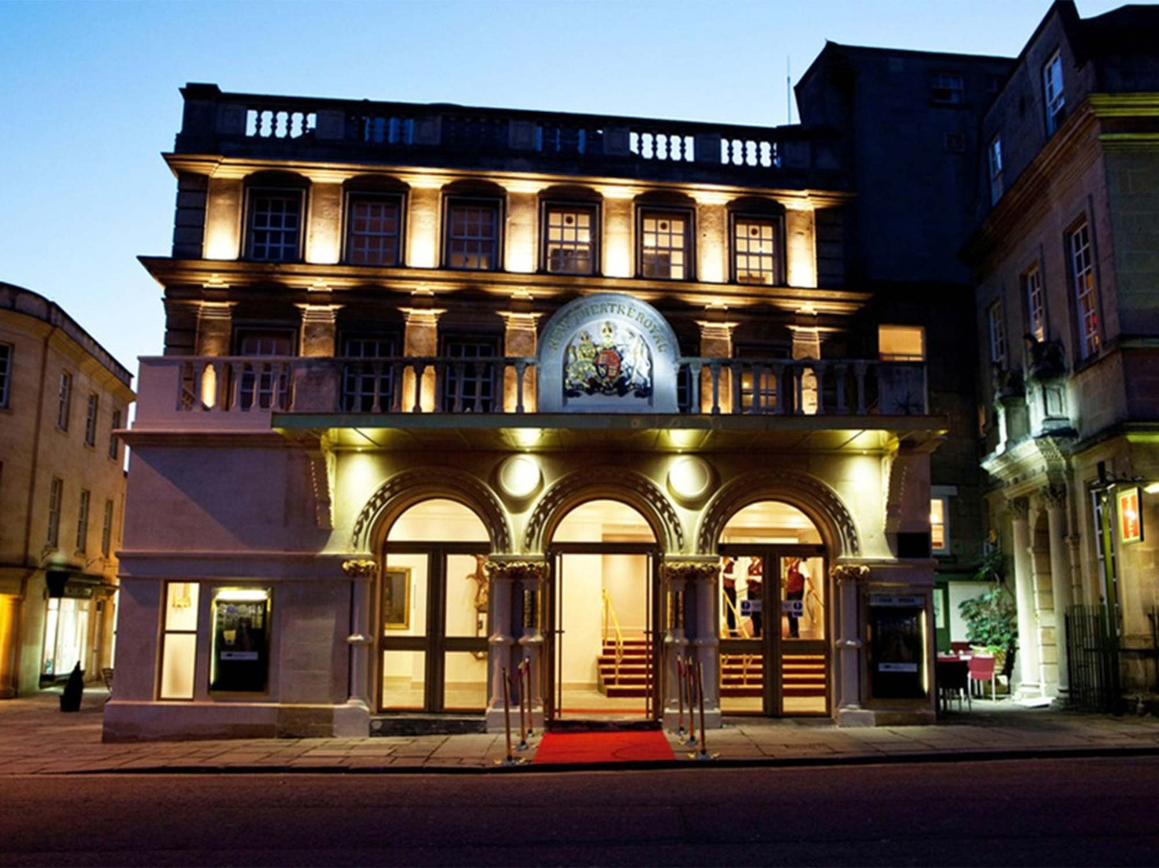**Front of House Manager Job Pack**

**Background to the Theatre Royal Bath**

The Theatre Royal Bath is one of the oldest continually working theatres in the country, having originally opened in 1805. A Grade II* listed building, it is described by the Theatres Trust as "One of the most important surviving examples of Georgian theatre architecture".

The Theatre Royal Bath comprises three auditoria – the historic Main House, the innovative Ustinov Studio and the Egg Theatre – which between them programme the best of UK touring and international theatre; many productions either prior to or direct from the West End, a mix of drama, comedy, ballet, opera and musical theatre and dedicated work for children and families throughout the year.

Theatre Royal Bath is a registered charity with a charitable purpose to provide high quality entertainment and

creative learning opportunities for the community. Regular visitors to the **Main House** include West End transfers from companies including the National Theatre, The Royal Shakespeare Company, Mischief Theatre (The Play That Goes Wrong) and touring companies including English Touring Opera, Rambert Dance and much-loved and award-winning UK and international actors. The Main House also hosts one-night events ranging from stand-up comedy with leading comedians to illustrated talks and music events.

Since 2011, under the direction of first Laurence Boswell, and more recently the internationally acclaimed and multi-award-winning opera and theatre director Deborah Warner, the 120 seat **Ustinov Studio** has transformed to an internationally acclaimed venue for innovative, creative theatre and performance including dance and opera with numerous productions transferring from the Ustinov Studio to the West End. These are presented alongside a continuing programme of high-quality small-scale touring theatre.

**The Egg** is one of the country’s most established theatres dedicated to children and young people. Since opening in 2005, it has presented over 900 plays, programming 60 different professional productions each year for audiences aged 0-18, hosting hundreds of theatre companies and introducing thousands of young people to live theatre. The Egg team works with many organisations to extend the role that arts and cultural venues play in young people’s lives, and fosters careers in the arts through: a partnership with Bath College (Bath Theatre Academy); apprenticeships; a Youth Theatre for ages 5-25; creative participation for 25+ and strong links with Bath Spa University, amongst many other projects.

Plans are underway to open a new community-oriented venue, provisionally titled **Venue 4,** within the existing Theatre Royal Bath footprint.

**Theatre Royal Bath Productions** is the theatre’s producing arm and has become one of the country’s most prolific producers and co-producers with productions touring nationally and regularly transferring to the West End and overseas.

Front of House Manager

Job Description

**Job Title:**  Front of House Manager

**Department:** Building & Operations, Theatre Royal Bath

**Reporting to**: General Manager

**Responsible for**: Deputy Front of House Manager and Casual Front of House staff (Main House & Ustinov Studio).

**Location:** Theatre Royal Bath

**Term:**  Full Time

**Hours**: 40 hours per week

**Salary & benefits:** £37,000 per annum

Complimentary tickets for most productions at each of the three auditoria (the Main House, Ustinov Studio, The Egg)

4 weeks holiday rising to 5 weeks after first year + Bank Holidays **Objectives:**

* To work as a member of the Building and Operations Department in a professional and supportive manner.
* To achieve and maintain the highest standards of excellence and customer service for the Theatre Royal Bath Main House and Ustinov.
* To achieve and maintain a safe and welcoming environment for customers, staff and visitors to the Main House and Ustinov.

**Key Tasks and Responsibilities include *but are not limited to:***

**Customer Service**

* To act as Duty FOH Manager for performances.
* To be responsible for the care and safety of all customers during performances and be the main point of contact for feedback during the performance.
* To act as the Theatre Licence holder’s nominated representative during performance.
* To deal with complaints and queries either by immediate action or in consultation by ensuring the relevant information is sent to the appropriate departments.
* To ensure all facilities and public areas available to visitors are of an appropriate standard and cleanliness at all times.
* To liaise with the Visiting Company Manager and discuss any special requirements of the performance including sale of merchandise.
* To ensure the Sennheiser system is readily available for customers during each performance, and organise servicing and replacement parts as required.
* To assist the Access Manager with facilitating access performances as necessary.
* To provide hospitality/ refreshments as required for internal and external functions across the site.

**Managing the Front of House Team**

* To line manage and be responsible for the care and safety of the FoH Staff team, monitoring standard, reporting to the General Manager as necessary.
* Ensure all staff are sufficiently trained and adhere to all matters relating to public safety, hygiene and licensing.
* To liaise with the General Manager about additional training requirements when identified and as appropriate, beneficial and necessary.
* Roster all FoH Staff for all performances, Special Events, Open Days and at any other time when required when members of the public are in attendance for the Main House, Ustinov and ancillary spaces.
* To hold regular Staff briefings and FoH Staff meetings and to take minutes.
* To recruit and induct Front of House staff as required.

**Commercial Operations**

* To oversee the FoH point of sale system (Tevalis) including maintaining and development as required.
* Alongside the Deputy Front of House Manager, oversee the operation of all theatre bars, ensuring that high standards of service, stock control and hygiene are maintained.
* To initiate and encourage ideas to increase sales and minimise costs in FoH areas, and in consultation with the General Manager.
* Be responsible for the profitability of the Front of House operation, working with the General Manager and Finance Director to ensure fiscal efficiency and to work within agreed budgets.
* Order programmes for each production in consultation with the Marketing Manager.
* To oversee the safe and proper management of financial transactions from all bars and sales points in according with Theatre Policy as directed by the Finance Director.

**Building Supervision**

* Uphold the theatre’s licensing requirements and assist the Building and Operations Department in ensuring compliance in all FoH areas.
* Manage the evacuation of the building in an emergency and for training purposes, as per agreed procedures.
* Be fully conversant with the Fire Alarm and Security Alarm systems.
* Attend Health & Safety meetings and ensure all Main House and Ustinov Working Practices and Risk Assessments are kept up to date.
* Report to the General Manager on all matters relating to the health, safety, and security of customers and Front of House Staff, building facilities and FoH maintenance.
* Ensure Health & Safety regulations including fire procedures are maintained and ensure accidents and near misses are recording appropriately, informing the General Manager at the first availability opportunity.
* Issue a show report for each performance, giving details of any action which may be required to respond to customer feedback and health & safety and operational concerns.
* Liaise with the theatre’s maintenance department when appropriate to ensure that all necessary repairs/ replacements are dealt with in a timely manner.
* To liaise with the Marketing Department to ensure that supplies of publicity material i.e., leaflets and brochures around the building are maintained and changed each week as appropriate.
* To order and maintain stocks of stationery, IT and catering consumables, ensuring best value.

**General**

* Be fully conversant with all Theatre Royal Bath policies.
* Attend Front of House, Building and Operations meetings as required.
* Always abide by the financial coding, management and monetary systems laid down by Theatre Royal Bath’s Finance Department.
* Act always in the best interests of Theatre Royal Bath.
* Undertake any further training as necessary.
* Carry out any further duties as reasonable requested by the General Manager or Theatre Director.

**Front of House Manager**

**Person Specification**

In completing your application, please refer to the Person Specification outlined below.

**Experience**

* At least 2 years proven experience in a customer service environment in a venue with an emphasis on excellent customer service skills.
* At least 2 years proven experience of being in a management position/ leading a team.
* Numerate and previous proven cash handling experience.

*Preferable*

* Office organisation.
* Management of electronic POS systems (Point of Sale/ till systems).
* Key holder responsibilities.
* Stock-take experience.
* Delivering staff training / inductions.

**Qualifications**

*Preferable*

* First Aid Qualification.
* Fire Marshal Qualification.
* Health & Safety Qualification.
* Appropriate vocational qualification in Customer Services or hospitality.

**Skills** *Essential*

* Computer proficient (Word, Outlook, & Excel).
* Excellent literacy and numeracy skills.
* Excellent organisation skills and a willingness to adapt to different roles within the department as may be required.
* Ability to work well with both self-motivation and willing to work under the direction of Senior staff.
* Very clear communication skills, both verbal and written, and with an ability to engage with both individuals and groups.
* Ability to multi-task and prioritise.
* Ability to problem solve.
* Excellent interpersonal skills.
* A flexible attitude towards hours of work and the cross-over of duties with other departments.
* Ability to exercise discretion at all times.

**Personal Qualities**

*Essential*

* Confident, enthusiastic, professional and self-motivated.
* Ability to work under pressure and to stay calm.
* Ability to prioritise tasks and use own initiative.
* A practical attitude towards problem solving.
* Welcoming and polite.
* The ability to work flexible shifts including weekends, Bank Holidays and evenings on a constant and reliable basis.
* A positive attitude towards learning and personal development.

*Preferable*

* Interest in theatre and the arts.
* Good knowledge of local area.

**Front of House Manager**

**Application Procedure**

**Deadline for Applications:** 12 noon, Wednesday 13 August 2025

**First Stage Interviews:** Monday 18 or Tuesday 19 August 2025

Any offer to a successful candidate will be conditional upon:

* Receipt of at least two independent written references, which are satisfactory to Theatre Royal Bath.
  + N.b: References produced by candidates will not be accepted.
* Verification of identity and Right to Work in the UK to be produced at interview stage.

**Application Procedure**

Please submit an up-to-date CV (2 pages max, PDF format) and respond to the four questions below.

Please use no more than 400 words per question.

1. **How are you suited to this role?** We are asking this question to hear about how your experience, knowledge and skills match the person specification.
2. **Tell us about what inspires and excites you in life (it doesn’t have to be theatre.)** We are asking this to learn more about you and what matters to you.
3. **Tell us about a challenging situation you faced at work and how you dealt with it.** We are asking this to learn how you face challenges or stressful situations.

Please email your CV and answers to your questions to: [recruitment@theatreroyal.org.uk](mailto:recruitment@theatreroyal.org.uk) quoting your name and ***Front of House Manager*** in the subject line).